BLANCO publishes an environmental product declaration for Silgranit sinks
More transparency on environmental impacts and improved planning for construction projects
Oberderdingen, 15 May 2026 – BLANCO publishes an Environmental Product Declaration (EPD) for its Silgranit product category. The provider of systems for the kitchen water place in private households thus creates transparent and reliable information on the environmental impacts of its products across the entire life cycle. For experts in retail, architecture, planning, property development and project development, an EPD thus simplifies and accelerates decision-making processes, for example in the context of tenders for construction projects where life-cycle assessments are mandatory.

High transparency across 36 environmental indicators

The EPD for Silgranit sinks covers all eight colours as well as the production sites in Sinsheim (Germany) and Most (Czech Republic). It maps the product life cycle in accordance with EN 15804 and takes into account raw material use, production, transport and the disposal phase. For each life cycle phase, relevant environmental impacts such as the carbon footprint, ozone depletion potential or water consumption are reported. In total, the EPD presents 36 environmental indicators in a transparent and data-driven manner.

The BLANCO EPD was prepared as part of a comprehensive life cycle assessment in accordance with EN 15804, verified by the independent Institut für Bauen und Umwelt e. V. (IBU) and listed on the European ECO platform. The EPD thus meets tender-related requirements such as the ‘Green Building’ criteria.

Simplified planning processes and a basis for product development

Ragnar Jehle, Head of Global Products at BLANCO, sees the EPD as sending an important signal to the market: “Our customers and retail partners welcome the fact that with the EPD we controbute to simplifying planning processes and thus facilitating participation in construction projects. What is also important to us: with the EPD we anchor the claim of transparency in our sustainability strategy and at the same time create a valuable data basis for the future development of our products.”

EPD publicly available

BLANCO makes the EPD available on its website in the sustainability section. It is also accessible on the platform of the Institute for Construction and the Environment (IBU): https://ibu-epd.com/veroeffentlichte-epds/

EPD at a glance

What is an EPD?
An Environmental Product Declaration (EPD) is a standardised document that provides neutral and verified data on a product’s environmental impacts over its entire life cycle. BLANCO has created such an EPD for the Silgranit sink product category.

What does an EPD state – and what does it not state?
An EPD transparently presents environmental indicators such as the carbon footprint or resource consumption. However, it does not assess the ‘sustainability’ of a product.

What is an EPD used for?
EPDs serve as a sound basis for decision-making, particularly in construction and kitchen planning, as well as in tenders and building certifications.

Who verifies an EPD?
EPDs are verified by independent bodies; in Germany, this is the Institut für Bauen und Umwelt e. V. (IBU), and they are valid for a maximum of five years.

Why is the EPD relevant for BLANCO?
The EPD supports transparent sustainability communication, simplifies planning and tendering processes, and provides a robust data basis for further product development.

Image:
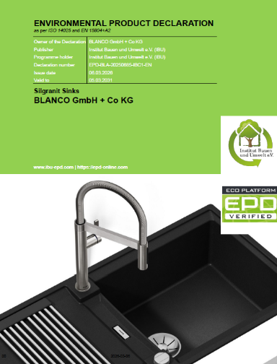

The ‘Silgranit Sinks’ EPD compiles data from 36 environmental indicators across the product life cycle of Silgranit sinks, thereby creating, for example, the basis for simplified participation in tenders.

Photo / Image credit: BLANCO

About BLANCO
BLANCO revolves around the kitchen water place in household kitchens. As an internationally established premium supplier with German roots, the company develops and manufactures products that boast award-winning design, high-quality materials and custom design options. The core of the portfolio is the modular BLANCO UNIT, which seamlessly combines bowls, mixer taps and water refinement systems, along with organisation systems for the base cabinet – all perfectly aligned in form and function. BLANCO strives for greater comfort, flexibility and delight every day at the kitchen water place. With an annual turnover of more than 392 million euros (2025) and over 1,400 employees worldwide, BLANCO is committed to this mission – at its German headquarters in Oberderdingen, Baden-Württemberg, and its national companies in Europe, Asia, Australia and North America.​

Contact for journalists,
journalists, editorial teams

